
Work Instruction for Dell Server Firmware Upgrade

Viatris
Work Instruction for Dell Server Firmware Upgrade

Contents
Contents 2
1. Introduction 3
1.1. Purpose 3
1.2. Scope of this Report 3
1.3. Audience 3
2. Approach and Methodology 3
2.1. Approach 3
2.1.1. Create a Change Request 3
2.1.2. Backup and Documentation 3
2.1.3. Schedule Downtime 3
2.1.5. Confirm Change Approval 3
3. Technical Details 3
3.1. Steps to upgrade the firmware version 3
4. Roles and Responsibilities 6
5. Escalation Matrix 6
6. Revision History 7

1. Introduction

1.1. Purpose
This document provides the steps to upgrade the firmware version in Dell Server.

1.2. Scope of this Report
The scope of this document is to describe how to upgrade the firmware in Dell server.

1.3. Audience
GIDC UNIX Group

2. Approach and Methodology

Approach

2.1.1. Create a Change Request
- Create a Change Request (CR) in ServiceNow for firmware upgrade.

2.1.2. Backup and Documentation
- Ensure all critical data on the server is backed up
- Record the current firmware and BIOS versions for reference.

2.1.3. Schedule Downtime
- Firmware updates require server reboots, so schedule maintenance by coordinating with the application team.

2.1.5. Confirm Change Approval
- Ensure that the change management process is completed and the change request is approved for implementation.

Technical Details

Steps to upgrade the firmware version
  - Login to the DELL IDRAC using SADM account and password.
  - Shutdown the server
  - Login to the DELL OME using SADM account and password.
  - Open the IMM and clear the job queue.
  - Open the DELL Manager
  - Go to Plugin Repository

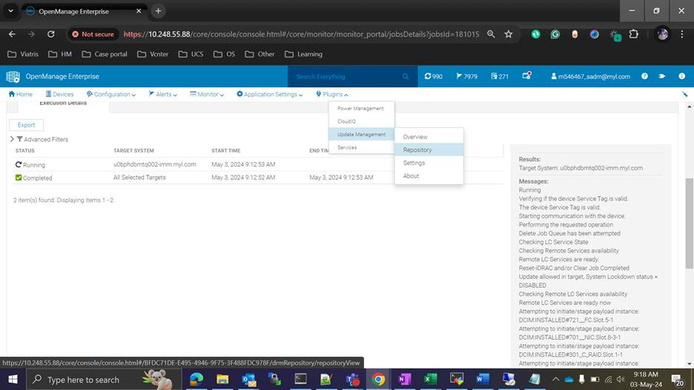
  - Click View report
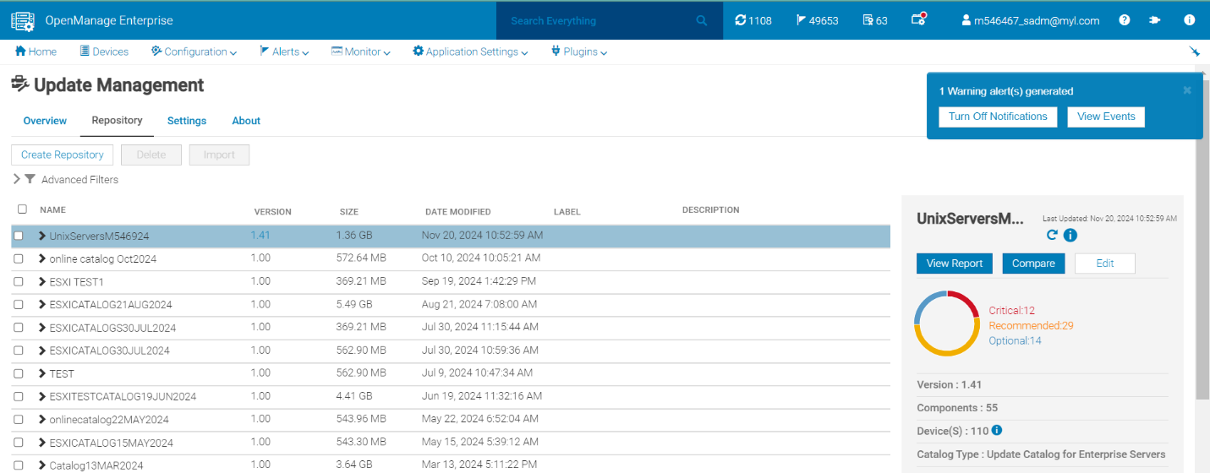

  - Search with server name:
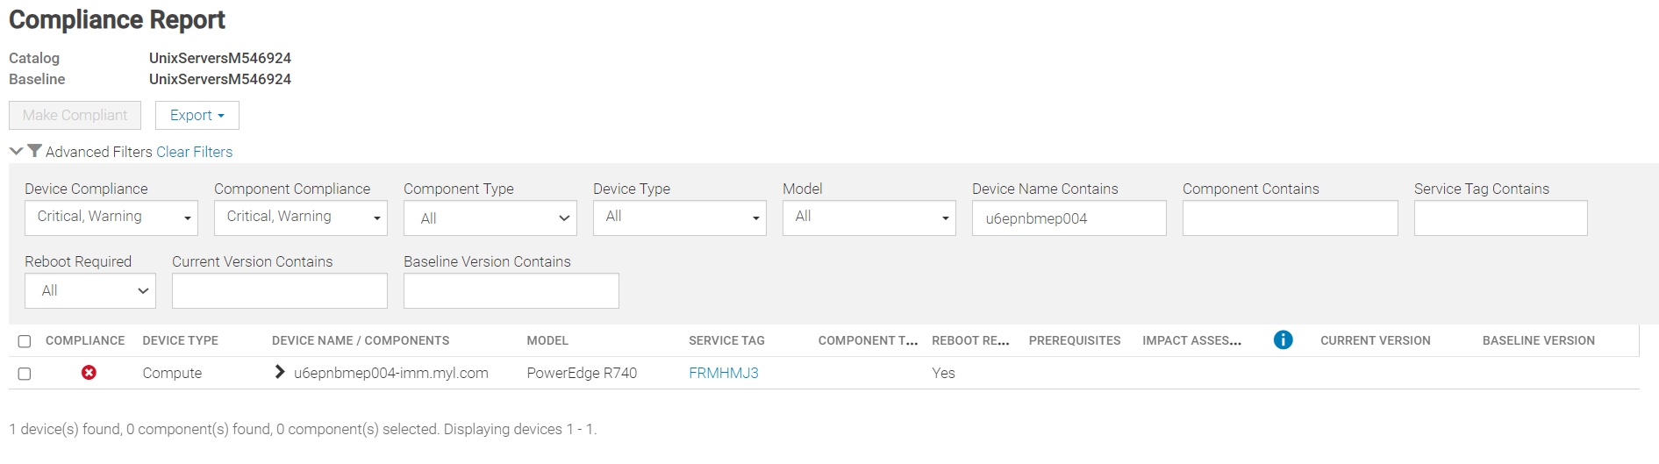
  - Expand the compute. Then choose the required firmware bundle packages which need to upgrade( select all)

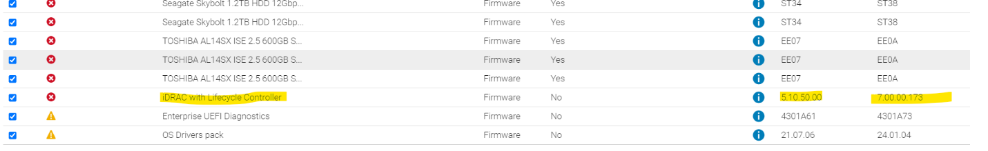
  - Click Make complaint
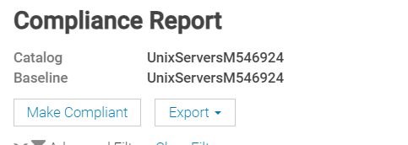

  - Click on update now button
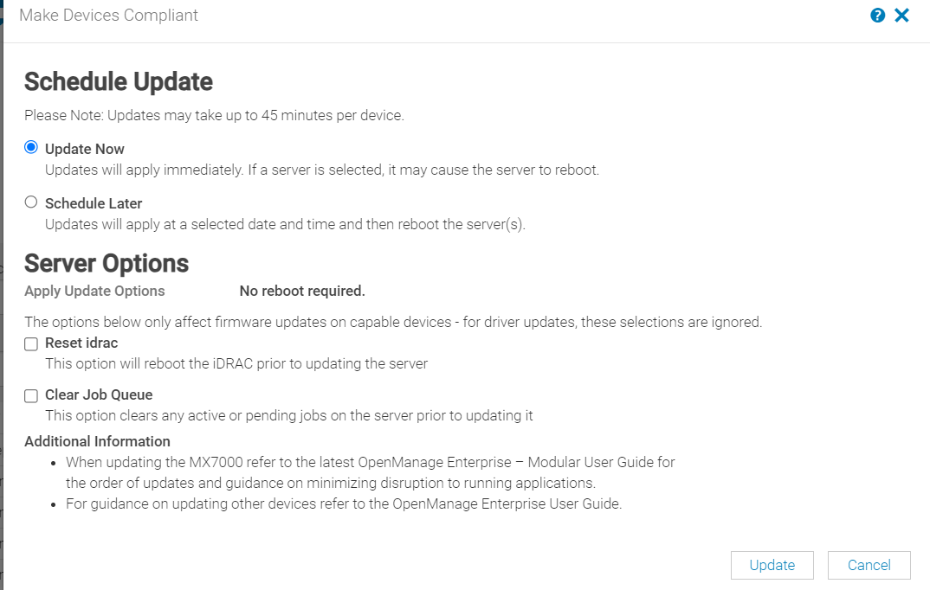
  - Once start the Update the check the Job queue

Roles and Responsibilities
Sl. No. | Roles | Responsibilities | Team Member Name
1. | Change Request | Respective Team / Unix Team | GIDC.unix_Run  GIDC.unix_Run@viatris.com
2. | Change Implementation | Respective Team / Unix Team | GIDC.unix_Run  GIDC.unix_Run@viatris.com

Escalation Matrix
Person Responsible | Role | Triggers When
Arun R  Arun.R@viatris.com  +91 9710677240 | Deputy Manager
Ashok Kumar R K  AshokKumar.RK@viatris.com  +91 9967735890 | Senior Manager
Zahir Hussain M ZahirHussain.M@viatris.com  +91 9840689462 | Senior Manager

6. Revision History

Date | Version | Summary of Changes | Author | Approved by
April 28 2025 | V1.0 | Created the Document | Benesh Selva Nesan P | Arun R
April 28 2026 | V1.1 | Validated the Document | Benesh Selva Nesan P | Arun R

